**User Guide**

When run Project – It’s show Login Page

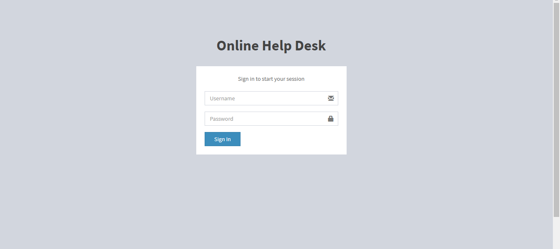

There are 3 type account.

**Admin:**

+ User Name: admin

+ Password: 123

**Support:**

+ User Name: sup01

+ Password: 123

**Student:**

+ User Name: student10

+ Password: 123

. Enjoy!